# Using WinSCP to Transfer Files to the Server

Open WinSCP and make a new connection to the webtech server. Use your subsite and your password. This is ‘webtech’ by default but it should be changed.

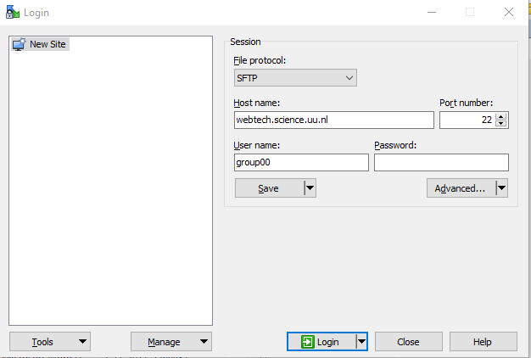

Go to Advanced and then tunnel, use the gemini server and log in using your SOLIS ID and password. This is your password, not the password for the webtech server.

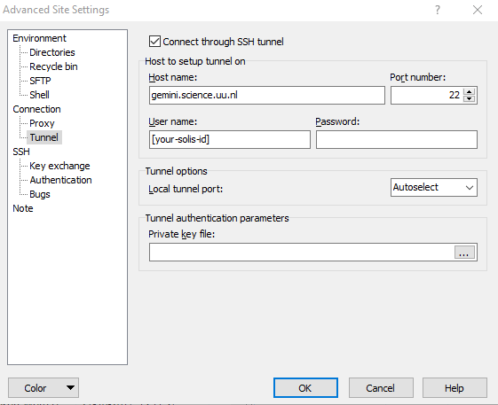

Go back and connect to the server and you’ll be able to transfer files.

